

Bangalore Water Management



March 31, 2024

Name: Thinesh.T

Roll no:71382006045

Domain: Data Analyst

College: SRI RAMAKRISHNA INSTITUTE OF TECHNOLOGY

HR Name: Mrs. Priya

**Introduction:**

"Water management is essential for sustainable resource use, addressing scarcity, and ensuring equitable access. This guide explores techniques, challenges, and policies vital for effective water conservation, treatment, and distribution."

**Importance of Water Management:**

Water management plays a critical role in ensuring the sustainable use and availability of one of our most precious resources: water. Effective water management is essential for addressing numerous global challenges, including water scarcity, pollution, and climate change impacts. By implementing efficient water management practices, we can ensure equitable access to clean water for present and future generations while also supporting ecosystems and economic development. Proper management involves strategies for conserving water through efficient use and minimizing waste, treating water to maintain quality standards, and distributing it effectively to meet various needs. Additionally, water management policies and regulations help govern usage, protect water sources, and promote sustainable practices. In essence, prioritizing water management fosters resilience against environmental pressures, enhances community well-being, and safeguards the health of both people and the planet. Ultimately, recognizing the importance of water management is crucial for fostering a sustainable future where water resources are preserved and utilized responsibly.

**Overview of Water Resources in Bangalore:Top of Form**

Bangalore, often referred to as the "Silicon Valley of India," is a rapidly growing metropolis and the capital city of the Indian state of Karnataka. Despite its cosmopolitan charm and technological advancements, Bangalore faces significant challenges in managing its water resources due to rapid urbanization, population growth, and environmental degradation.

**Water Sources:**

**Lakes:** Bangalore was once known for its numerous lakes, which served as vital sources of water and contributed to the city's ecosystem. However, over the years, many lakes have been encroached upon, polluted, or converted for other uses, leading to a drastic reduction in their numbers and quality.

**Rivers:** The city is not directly located on any major river, but it is situated close to the Arkavathy River, which has historically been a significant source of water for the region. However, like many rivers in India, the Arkavathy has been subject to pollution and reduced flow due to various factors, including deforestation and industrial activities.

**Groundwater:** Groundwater has been a crucial source of water for both urban and rural areas in and around Bangalore. However, unsustainable extraction practices, particularly for urban development and agriculture, have led to declining groundwater levels and quality. Overexploitation has resulted in the depletion of aquifers, leading to issues such as land subsidence and saltwater intrusion in coastal areas.

**Water Availability and Quality:**

**Scarcity:** Bangalore faces water scarcity issues, exacerbated by irregular rainfall patterns, inadequate storage facilities, and inefficient distribution systems. The demand for water exceeds the available supply, leading to frequent shortages, especially during dry seasons.

**Pollution:** Pollution of water bodies is a significant concern in Bangalore. Industrial discharge, untreated sewage, solid waste dumping, and agricultural runoff contribute to the contamination of lakes, rivers, and groundwater. This pollution not only affects the availability of potable water but also impacts aquatic ecosystems and public health.

**Challenges in Water Management:**

Challenges in water management in Bangalore include rapid urbanization, population growth, pollution of water bodies, depletion of groundwater levels, and climate change impacts. The city's infrastructure struggles to keep pace with the increasing demand for water, leading to shortages and inequitable distribution. Encroachment on lakes and rivers exacerbates the scarcity, while industrial discharge and untreated sewage contaminate water sources, posing risks to public health. Groundwater depletion due to over-extraction compounds the problem, further threatening water security. Climate change exacerbates these challenges, with erratic rainfall patterns and rising temperatures impacting water availability and exacerbating droughts. Addressing these multifaceted challenges requires coordinated efforts, innovative solutions, and robust policies to ensure sustainable water management in Bangalore.

**Current Water Management Practices:**

Current water management practices in Bangalore include a mix of centralized water supply systems, rainwater harvesting, wastewater treatment, and conservation measures. The Bangalore Water Supply and Sewerage Board (BWSSB) oversees water distribution and treatment, managing several reservoirs and treatment plants to supply water to the city. Rainwater harvesting is promoted both at the individual and community levels to recharge groundwater and reduce runoff. Additionally, the BWSSB operates wastewater treatment plants to treat sewage before discharge. Water conservation initiatives, such as public awareness campaigns and incentives for water-saving technologies, aim to reduce water demand. Despite these efforts, challenges persist, including infrastructure deficits, water quality issues, and inequitable distribution. Future strategies emphasize sustainable water management practices, investment in infrastructure upgrades, and community engagement to address these challenges effectively.

**Water Bodies used to Analyse Water Management:**

**Abbigere Lake:**

Abbigere Lake is located in the northwest part of Bangalore.

It serves as a vital water resource for the local community, supporting irrigation and groundwater recharge.

Over the years, the lake has faced threats from encroachment, pollution, and siltation, leading to a decline in water quality and biodiversity.

Efforts are underway to revive and rejuvenate Abbigere Lake through community engagement, restoration projects, and sustainable management practices.

**Agara Lake:**

Agara Lake is situated in the southern part of Bangalore, near HSR Layout and Koramangala.

Historically, Agara Lake played a crucial role in groundwater recharge and flood control in the region.

However, rapid urbanization and encroachment have degraded the lake's ecosystem, leading to pollution and shrinking water bodies.

Various stakeholders, including local communities, NGOs, and government agencies, are working towards restoring Agara Lake through conservation efforts, desilting, and sewage diversion projects.

**Akshayanagara Lake:**

Akshayanagara Lake is located in the Akshayanagara area, near Electronic City in southern Bangalore.

The lake serves as a recreational space for nearby residents and supports biodiversity.

Like many lakes in Bangalore, Akshayanagara Lake faces threats from encroachment, sewage inflow, and solid waste dumping.

Restoration efforts focus on cleaning, desilting, and fencing the lake to prevent further degradation and promote ecological conservation.

**Allalasandra Lake:**

Allalasandra Lake is situated in the northern part of Bangalore, near Yelahanka.

The lake is part of the Allalasandra Lake Bird Conservation Reserve and provides habitat for migratory birds and local wildlife.

Despite its ecological importance, Allalasandra Lake has experienced pollution and encroachment, endangering its biodiversity.

Conservation efforts include habitat restoration, wetland management, and community engagement to protect and preserve the lake's ecological integrity.

**Technologies and Solutions:**

**Smart Water Management Systems:** Integration of IoT sensors, data analytics, and remote monitoring to optimize water distribution, detect leaks, and improve efficiency in water usage.

**Rainwater Harvesting**: Installation of rainwater harvesting systems at individual homes, commercial buildings, and public spaces to capture and store rainwater for non-potable uses such as landscaping, flushing toilets, and groundwater recharge.

**Wastewater Treatment and Reuse:** Implementation of decentralized wastewater treatment plants (DWTPs) and tertiary treatment facilities to treat sewage and industrial effluents for reuse in irrigation, industrial processes, and non-potable applications, reducing pressure on freshwater sources.

**Desalination:** Exploration of desalination technologies to convert seawater or brackish water into freshwater, providing an alternative water source to supplement conventional supplies.

**Community-Based Initiatives:** Promotion of community-led projects such as lake rejuvenation, watershed management, and conservation efforts to restore water bodies, improve water quality, and foster community resilience.

**Output:**

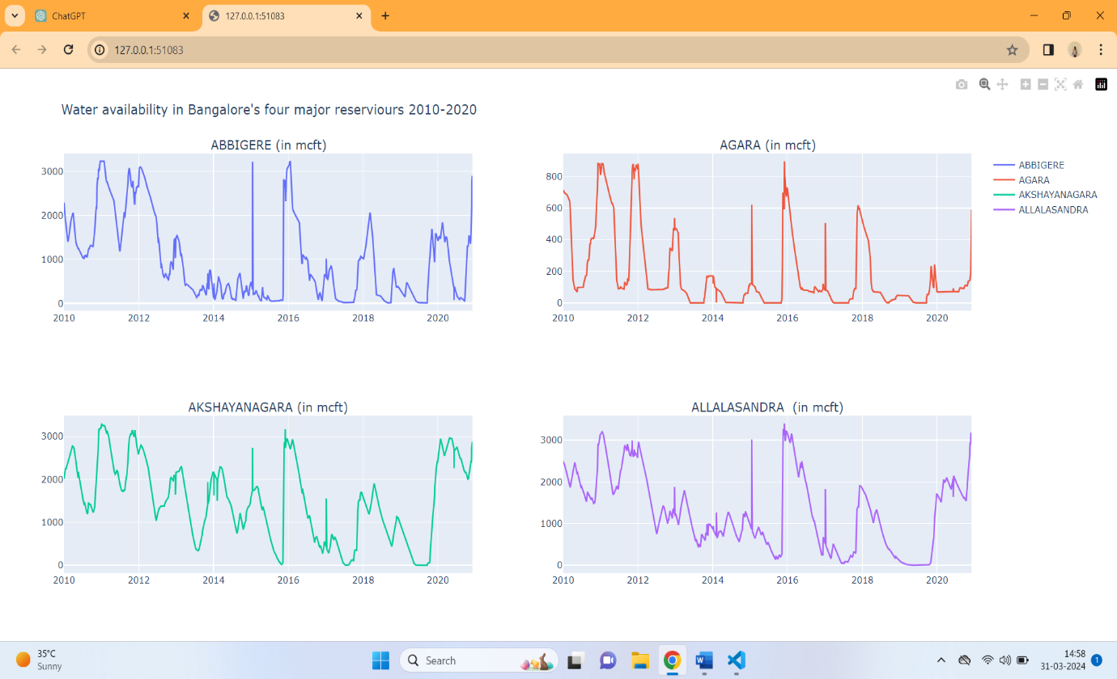

Future Prospects and Recommendations**:**

**Infrastructure Upgrades:** Investment in water infrastructure, including pipelines, treatment plants, and distribution networks, to improve efficiency, reduce losses, and meet growing water demands.

**Water Conservation Measures:** Implementation of water conservation practices, such as promoting water-saving fixtures, incentivizing rainwater harvesting, and enforcing water-use restrictions, to reduce demand and preserve freshwater resources.

**Climate Resilience:** Development of climate-resilient water management strategies, including drought preparedness plans, watershed management, and flood control measures, to mitigate the impacts of climate change on water availability and quality.

**Policy Reforms:** Enactment of comprehensive water policies, regulations, and governance frameworks that prioritize sustainability, equity, and public participation in decision-making processes.

**Community Engagement:** Engagement of stakeholders, including government agencies, businesses, civil society organizations, and the public, in collaborative efforts to address water challenges, foster awareness, and build local capacity for sustainable water management.

**Conclusion:**

In conclusion, water management in Bangalore is a complex and pressing issue that requires urgent attention and concerted action from all stakeholders. The city's rapid urbanization, coupled with environmental degradation and climate change, has placed immense strain on its water resources, leading to scarcity, pollution, and inequitable distribution.

**References:**

http://kaggle.com/